Phase 7 — Integration & External Access

**🎯 Goal**

Integrate Salesforce with external systems (e.g., SMS provider, Payment Gateway) using secure callouts and Named Credentials. This enables counselors to send reminders and process payments securely.

**1. Named Credentials**

Why: Simplifies external API authentication (avoids Remote Site Settings).  
  
Setup:  
1. Go to Setup → Quick Find → Named Credentials → New.  
2. Configure:  
- Label: MySMSProvider  
- Name: MySMSProvider  
- URL: https://api.smsprovider.com/v1  
- Identity Type: Named Principal  
- Authentication Protocol: No Authentication (API key managed via Custom Metadata)  
**Step 2: Custom Metadata for API Keys – Tutor Match**

**Purpose:**

* Avoid hardcoding API keys in Apex.
* Makes it easy to manage SMS or Payment Gateway credentials centrally.

**Tutor Match Use Case:**

* **SMS Provider:** Send session reminders to students or parents.
* **Payment Gateway:** Process session fees securely.

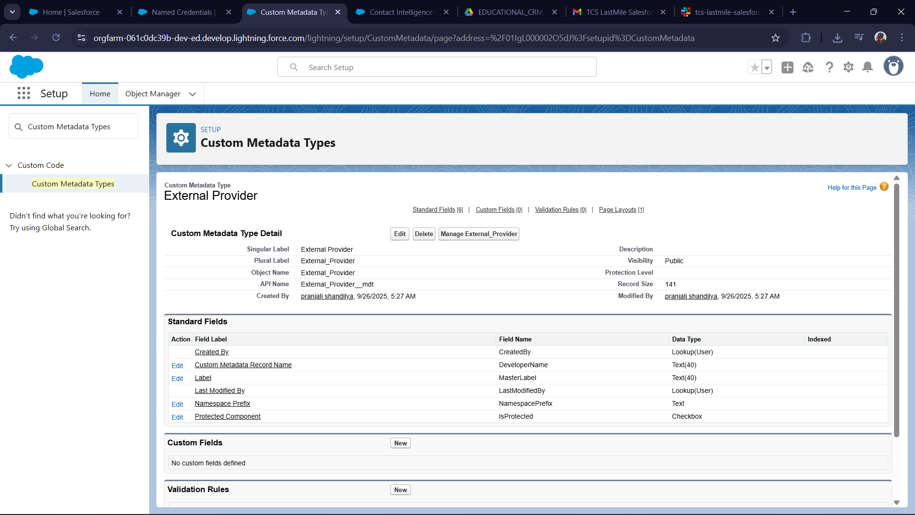 **3: Web Services (REST Callouts) – SMS Integration**

**Purpose:**

* Send automated session reminders to students or parents using an external SMS API.
* Uses Queueable Apex for asynchronous processing, so it doesn’t block the UI**.**

**Tutor Match Use Case:**

* Notify a student/parent about an upcoming session.
* Pull API key from Custom Metadata (External_Provider__mdt) for security

**5: Payment Gateway Stub**

PaymentService.cls  
- Annotated with @AuraEnabled for LWC calls.  
- Sends POST /charges request to callout:PaymentProvider/charges.  
- Accepts token, amount, currency.  
- Returns deserialized JSON re

**4. Callouts Test Framework**

MockSmsResponse.cls  
 Simulates provider’s success response.

**6. Platform Events & Change Data Capture (Future Scope)**

Salesforce supports event-driven integration.  
Example: Trigger event when Enrollment__c is created → notify external system.

**7. Salesforce Connect (Future Scope)**

Not implemented here.  
Use case: Read-only access to external databases via OData, without storing data in Salesforce.

**✅ Result**

* Tutors/parents can pay for sessions directly from Salesforce.
* Payment processing is **secure, asynchronous, and easily integrable with LWC**.
* Response can be stored in a **custom Payment__c object** to track transaction status.